Introduction:

This project introduces a comprehensive fitness and wellness tracking application designed to meet the growing need for simple, meaningful, and user centered health management. Many individuals struggle to maintain consistent routines because their health information is scattered across multiple apps, each focusing on only one part of their lifestyle. This application brings everything together by integrating physical activity tracking, nutrition monitoring, and wellness insights into a single, accessible platform. The goal is to give users a clear understanding of how their daily choices influence their long term well-being and to help them make informed decisions through organized, data driven feedback. By presenting information in a way that is easy to understand and personally relevant, the app aims to reduce confusion, increase awareness, and support healthier habits.
Beyond tracking numbers, this project focuses on motivation, accountability, and long term engagement. Many people begin their health journey with excitement but lose momentum when progress becomes difficult to see or understand. This application addresses that challenge by offering personalized recommendations, visual progress indicators, and meaningful insights that encourage users to stay committed. Our team plans to make tracking your health successful by creating an experience that feels supportive, intuitive, and genuinely helpful. By combining fitness, nutrition, and wellness into one cohesive system, the project aims to provide a tool that not only records data but actively guides users toward a healthier and more balanced lifestyle. Below are examples of a Fitness & Wellness Tracker:

Project Organization:

Position | Names | Description
Group Leader | Emily | Oversees team coordination, deadlines, communication, and project direction.
Designer | Bithiah | Creates UI layouts, visual design, and ensures the app is user‑friendly.
Coders / Programmers | Abdallah, Bithiah, Ryan | Build the app’s features, database, and functionality.
Organizer | Emily | Manages schedules, meetings, and keeps project materials organized.
Testers | Ryan and Abdallah | Will test features, find bugs, and ensure smooth performance.
Documentation | Whole Team – Ryan, Abdallah, Emily, Kylie, and Bithiah | Will maintain written documentation and project records.

Two people were originally in our team who over the course of the class term left the class and became unable to work on the project in any capacity, though one person was able to help for a number weeks until they left, while the other person left prior to the first team meeting.

Risk Analysis:

*(indicates risk factor had impact on the project outcome despite planning)
Risks | Risk Level | Risk Planning
Incomplete or Late Delivery*  This risk involves the project not being finished by the due date. The workload, unexpected issues, or delays could slow progress. | Moderate | The team will follow a realistic schedule, hold weekly check-ins, and prioritize core features to stay on track.
Data Loss or Cloud Storage Failure  Project files or user data could be lost if cloud services fail or files become corrupted. | Low | The team will keep multiple backups, use GitHub regularly, and store important files in more than one location.
Team Member Unavailability*  A team member may become unable to participate due to illness, emergencies, or schedule conflicts. | Moderate | Documentation will be kept updated so tasks can be transferred if needed, and responsibilities will be shared when possible.
Too Many Features*  The team may try to add more features than originally planned, which could delay the project or leave parts unfinished. | High | The project scope will be clearly defined early, and no new features will be added without group approval.
Technical Issues*  Development tools, databases, or the app itself may crash, break, or fail to function correctly. | Moderate | The team will use reliable tools, save work frequently, and reinstall or switch tools if problems occur.
Incomplete Testing / Bugs*  Not enough time for testing may result in bugs, inaccurate tracking, or broken features. | High | Testing will begin early, and each feature will be tested as soon as it is built to avoid last-minute issues.

Hardware & Software Requirements:

Hardware Requirements

- A laptop or desktop computer capable of running development tools
- Reliable internet connection for collaboration and version control
- Mobile device (Android or iOS) for testing the app interface
- External storage or cloud storage for backups
- Optional: second monitor to improve workflow and multitasking

Software Requirements
- Visual Studio Code or Android Studio for development
- GitHub for version control and team collaboration
- Firebase or SQLite for database management
- Figma or Canva for UI/UX design and wireframing
- Web browser for research, documentation, and testing
- Communication tools such as Microsoft Teams or Google Chat
- Microsoft Word for documentation and reporting

Case Diagram:

Fitness & Wellness App

Log Workout
Log Meals

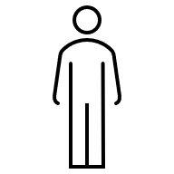
User
View Daily Summary

Track Progress

Project Overview:

The Fitness and Wellness Tracking Application is designed to provide users with a centralized, intuitive, and supportive environment for managing their daily health routines. As health and wellness become increasingly important in modern life, individuals often rely on multiple apps to track different aspects of their well‑being. This fragmentation makes it difficult to maintain consistency, identify patterns, or stay motivated. Our project aims to solve this problem by integrating fitness tracking, nutrition logging, and wellness insights into a single, cohesive system.
The application will serve a wide range of users, from beginners who are just starting their health journey to individuals who already maintain active lifestyles but want a more organized way to track their progress. By offering a unified platform, the system reduces the cognitive load associated with switching between apps and helps users stay engaged over time. The project also emphasizes accessibility, ensuring that the interface is easy to navigate and that features are presented in a clear, meaningful way.

Project Purpose:

The purpose of this project is to create a tool that empowers users to make informed decisions about their health. Many people struggle to understand how their daily choices—such as food intake, physical activity, and sleep habits—affect their long‑term well‑being. By consolidating this information into one place, the application provides users with a holistic view of their lifestyle patterns. This visibility encourages accountability and supports long‑term habit formation.
Additionally, the project aims to promote motivation through personalized insights and visual progress indicators. Users will be able to see how their actions contribute to their goals, which can help sustain engagement even when progress feels slow. The system is designed to be supportive rather than overwhelming, offering guidance without judgment.

Project Scope:

The scope of this project included the development of core features that support fitness tracking, and nutrition logging. These features will be implemented in a way that prioritizes usability and clarity. The project will focus on essential functionality first, with the potential for additional features to be added in future iterations:

In‑Scope Features:

- Daily activity tracking (workouts, exercise logs)
- Nutrition logging with calorie and macro tracking

Out‑of‑Scope Features:

- Wearable device integration
- Social media sharing
- Premium subscription tiers
- Advanced AI‑driven coaching
- Multi‑language support

Assumptions:
Several assumptions guide the planning and development of this project. It is assumed that:

- Team members will contribute based on their availability and skill sets.
- Requirements may evolve as the project progresses.
- The application will be developed primarily for mobile devices.
- Free or student‑licensed tools will be used for development.
- The project schedule will be finalized once all team members confirm availability.

Constraints:

The project is subject to several constraints, including:
- Limited time within the semester
- Varying levels of technical experience among team members
- Dependence on free tools and resources
- Potential delays due to incomplete participation
- Limited access to advanced testing devices

Development Approach:

The development approach outlines the methodology, tools, and processes the team will use to complete the project. A structured approach ensures that tasks are completed efficiently and that the final product meets the intended goals.

Methodology:

The team will follow an Agile‑inspired methodology, which is well‑suited for student projects and evolving requirements. Agile emphasizes flexibility, collaboration, and iterative progress. Instead of attempting to complete the entire project in one long cycle, the team will break the work into smaller, manageable sprints.
Each sprint will focus on a specific set of tasks, such as designing the user interface or implementing a particular feature. At the end of each sprint, the team will review progress, identify challenges, and adjust plans as needed. This approach allows the team to adapt to unexpected issues and ensures that progress continues even if certain tasks take longer than expected.

Tools and Technologies:

The project will utilize a combination of development, design, and collaboration tools to support efficient workflow and communication.

Development Tools

- Visual Studio Code and Android Studio
- GitHub for version control and filesharing
- Firebase or SQLite for database management

Design Tools

- Figma or Canva for UI/UX design
- Shared cloud folders (Github and Discord) for storing design assets

Collaboration Tools

- Zoom and Discord for communication
- Shared documents for planning and documentation

Testing Tools

- Built‑in debugging tools
- Physical devices for final testing (if available)

Requirements:

This section outlines the functional and non‑functional requirements that define the expected behavior and performance of the application.

Functional Requirements:

Functional requirements describe what the system must do. These requirements ensure that the application provides the necessary features for users to track their health effectively.
- Fitness Tracking
- Users must be able to log daily activities.
- The system must track steps, workouts, and exercise duration.

- Nutrition Logging
- Users must be able to log meals.
- The system must calculate calories and macronutrients.

Non‑Functional Requirements:

Non‑functional requirements describe how the system should perform.
- Usability
- The interface must be intuitive and easy to navigate.

- Performance
- The system must respond quickly to user interactions.

- Security
- User data must be stored securely.

- Compatibility
- The app must work on modern devices compatible with software requirements.

- Reliability
- The system must handle errors gracefully.

Work Breakdown Structure (WBS):

The Work Breakdown Structure divides the project into major phases and tasks. This structure helps the team stay organized and ensures that all necessary work is accounted for.
Phase 1: Planning
- Define project goals
- Identify core features
- Assign team roles
- Gather initial requirements
- Create early sketches and concepts
Phase 2: Design
- Develop UI wireframes
- Create navigation flow diagrams
- Draft database schema (TBD)
- Review design with team
- Make revisions based on feedback
Phase 3: Development
- Implement user authentication
- Build activity tracking module
- Add nutrition logging functionality
- Develop wellness insights system
- Integrate database
- Conduct internal testing
Phase 4: Testing
- Perform unit testing
- Identify and fix bugs
- Conduct user acceptance testing
- Test performance on multiple devices
Phase 5: Deployment
- Prepare final build
- Review documentation
- Assemble submission package

---
Project Schedule:

A detailed project schedule will be added once all team members provide their availability and estimated task durations. A Gantt chart or timeline will be included in this section once finalized.
---
Monitoring & Reporting
To ensure consistent progress, the team will use the following monitoring and reporting methods:
- Weekly meetings to review progress
- GitHub commits to track development
- Shared task boards to monitor assignments
- Documentation updates after each sprint
- Testing reports to track bugs and fixes

Appendices:

Appendix A: User Stories
- As a user, I want to track my daily steps so I can monitor my activity level.
- As a user, I want to log my meals so I can understand my nutritional intake.
- As a user, I want to view progress charts so I can stay motivated.
- As a user, I want reminders, so I don’t forget my health goals.
- As a user, I want personalized insights so I can make better decisions.
- As a user, I want to track my hydration so I can stay healthy.
- As a user, I want to set goals so I can work toward long‑term improvements.

Appendix B: UI Mockups
To be added once the design team finalizes wireframes.

Appendix C: UML Diagrams
- Use Case Diagram (TBD)
- Class Diagram (TBD)

Appendix D: Additional Notes

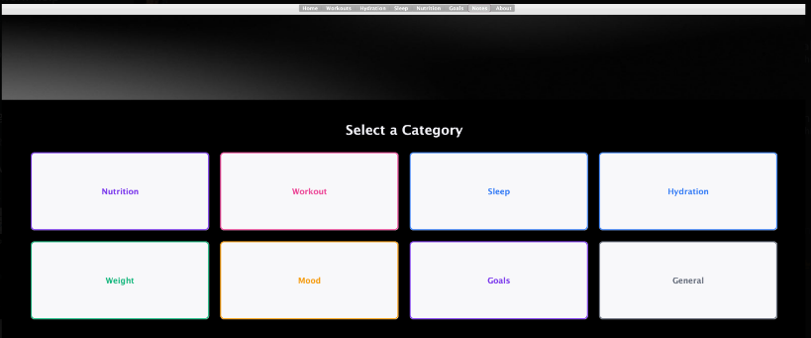
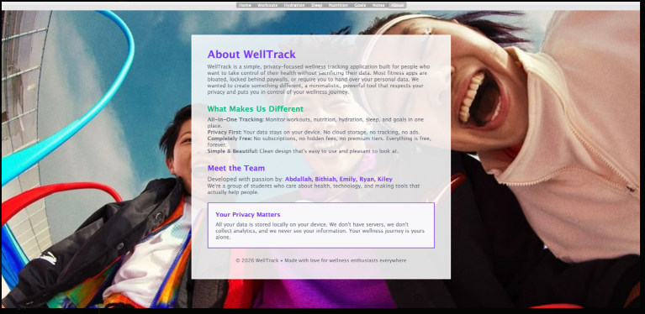
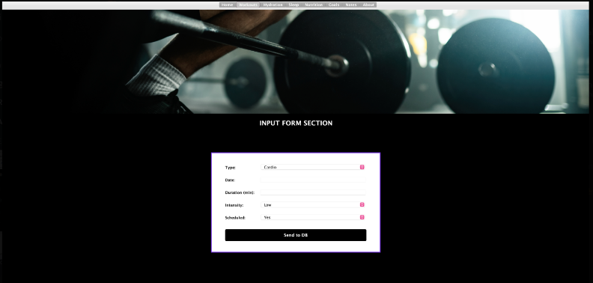
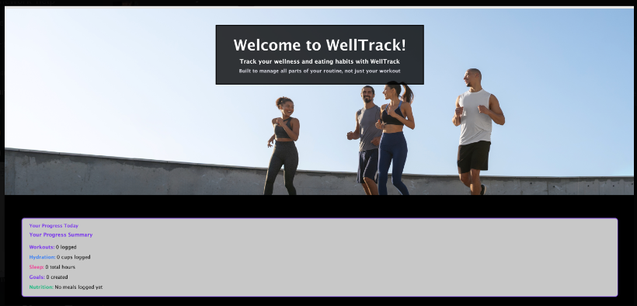
This section will include any extra materials, screenshots, or diagrams created during development.

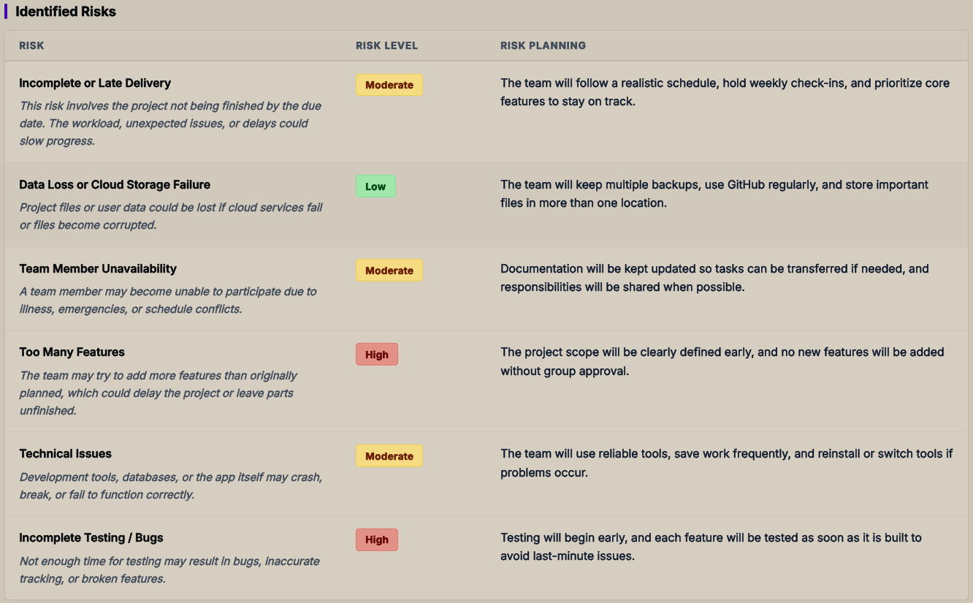

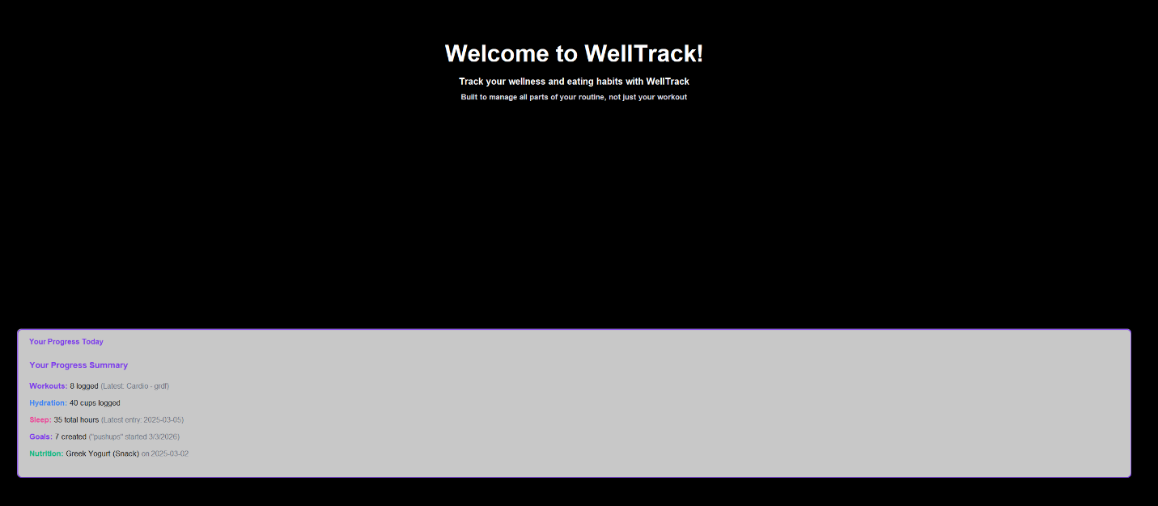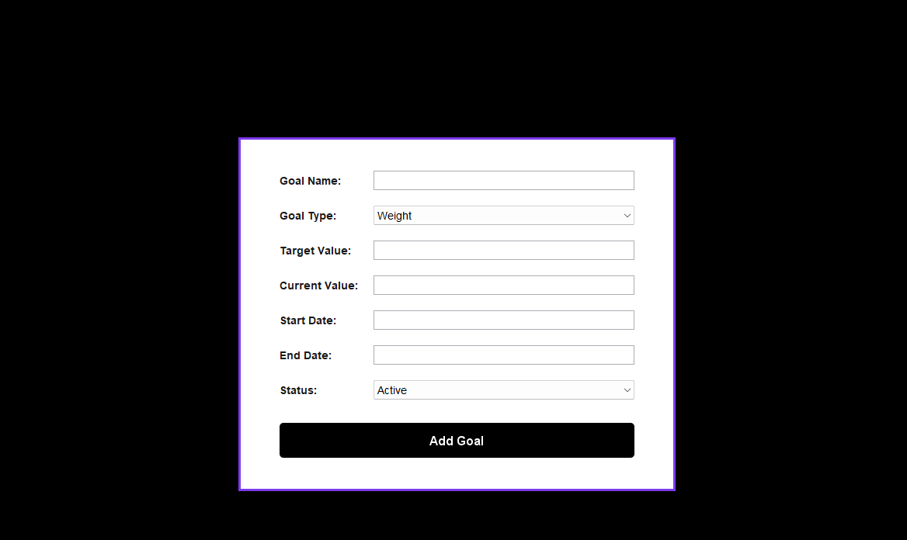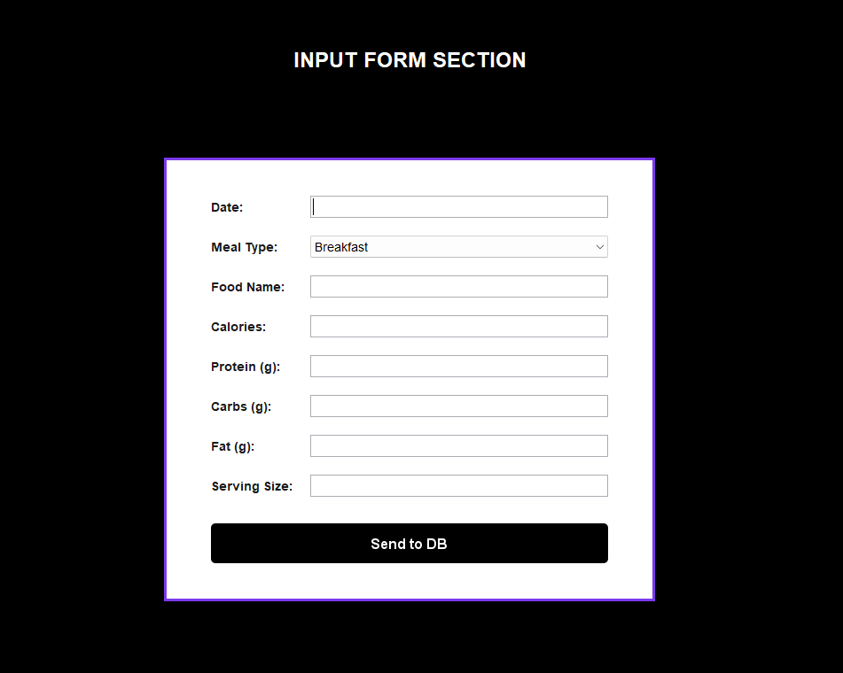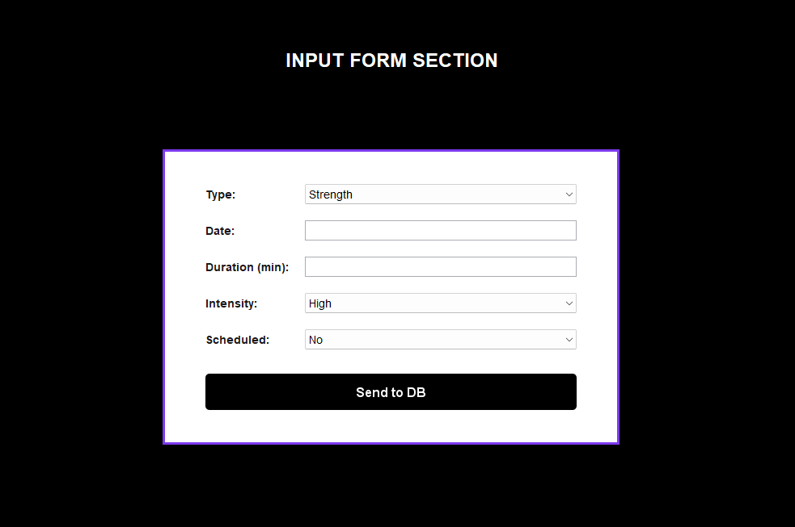

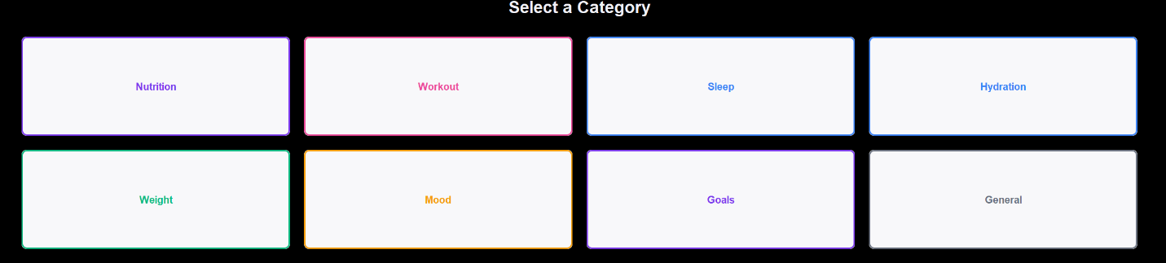

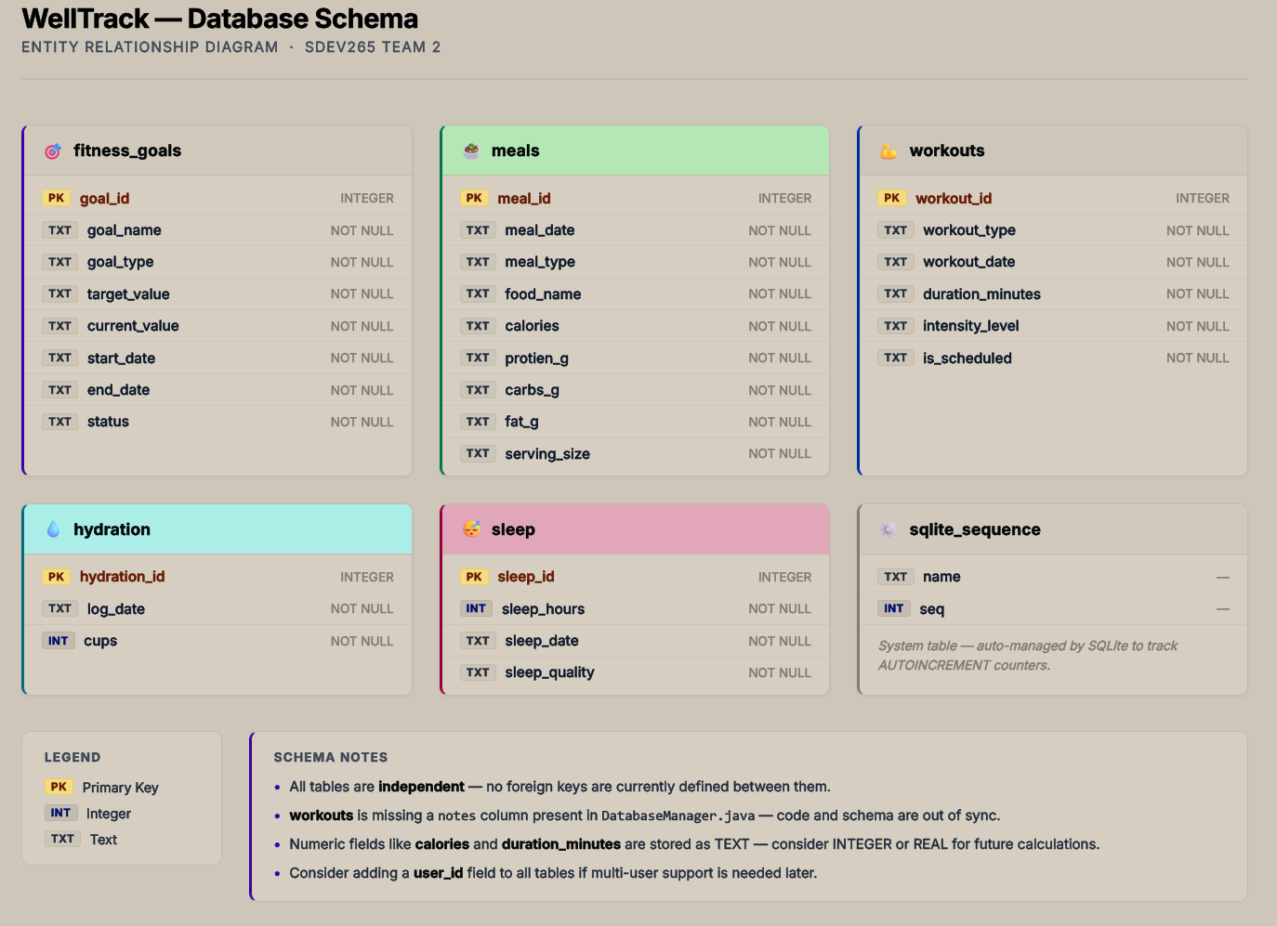

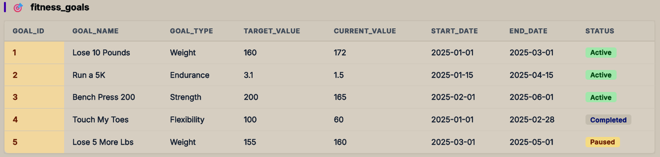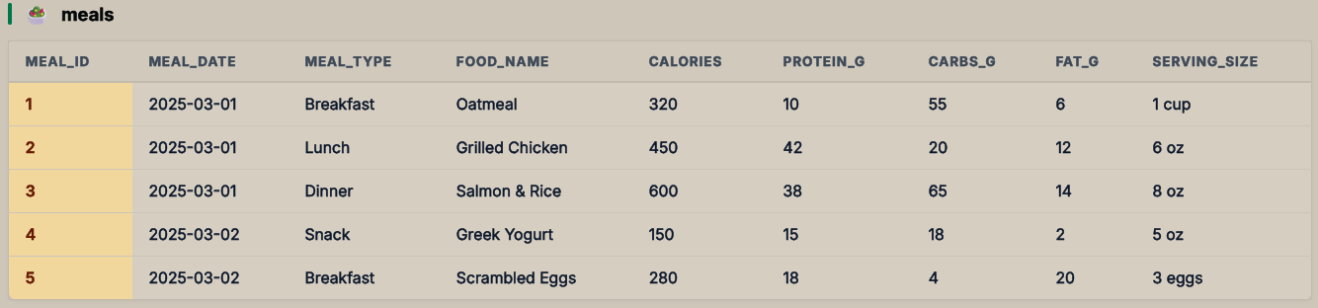

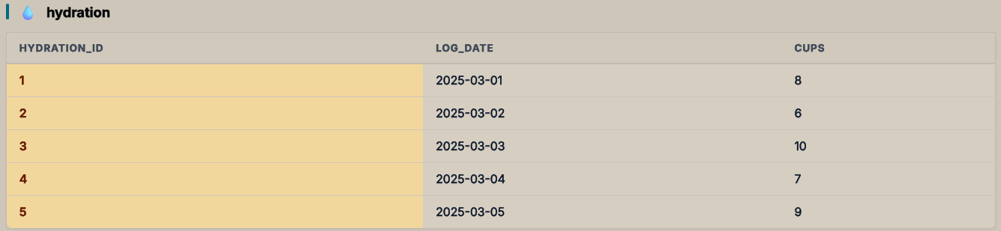

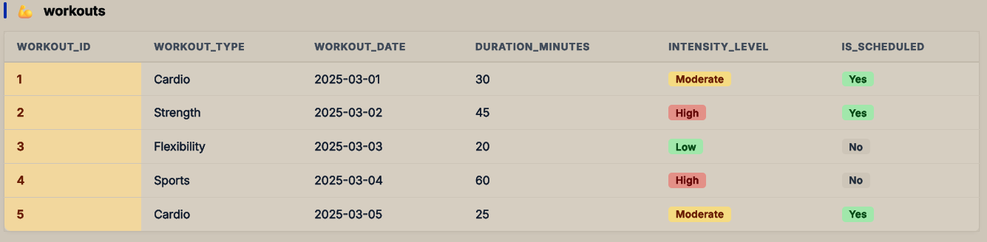

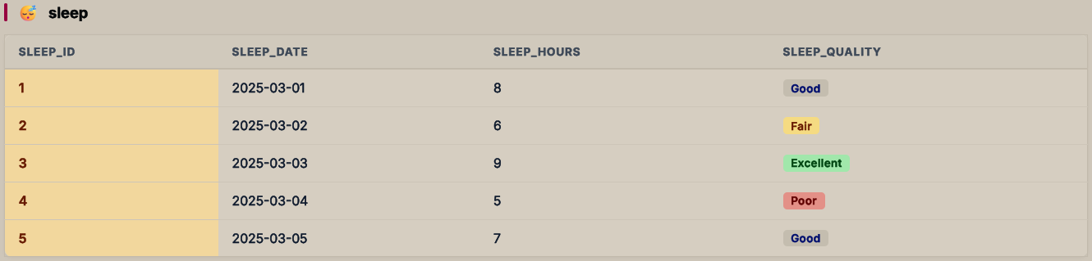

Testing:

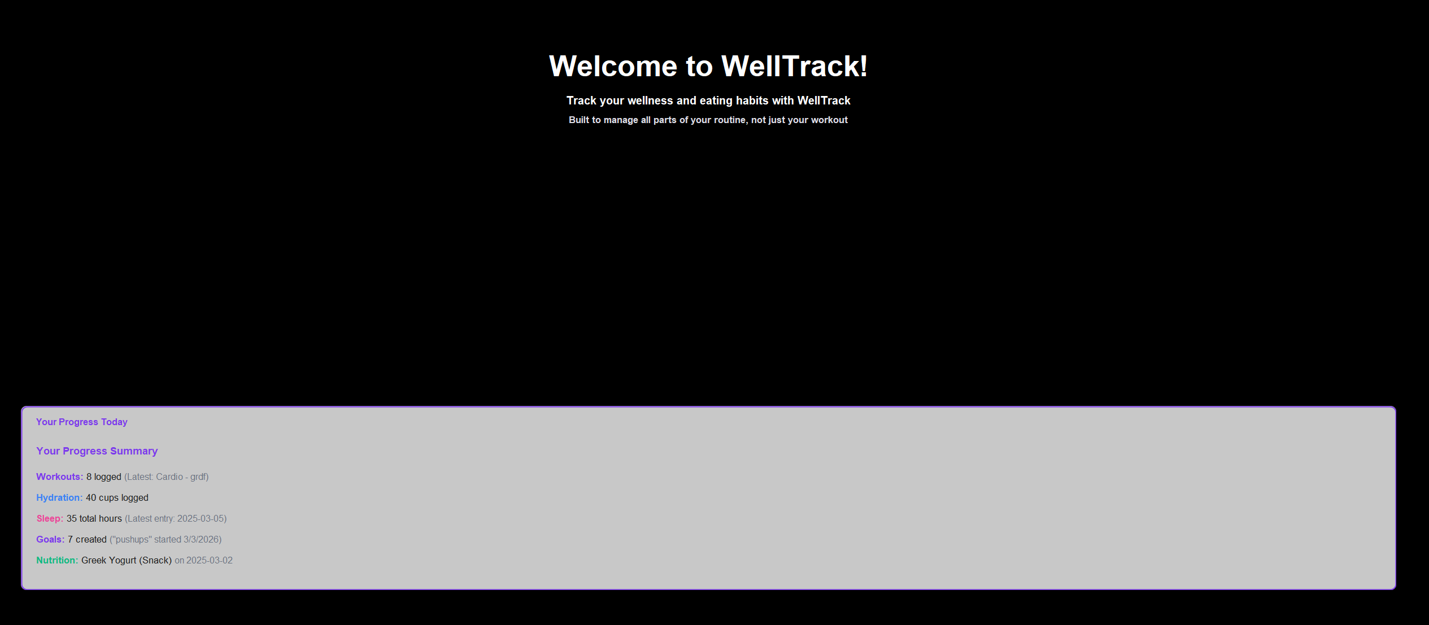

This section alongside the sample data in the database shows that there is a link between information displayed in the application and the data stored in the database.

